Lab 3 Report Template

1. In coffee can, there are n black beans and m white beans, each time two beans will be taken out: if they are with same color, throw away both, then put in one black bean; if they are with different color, throw away the black bean, put back the white bean.

* 自己设计采用list结构表示每个bean，存储其颜色(black/ white)，实现下表中list的接口
* 每次取法：产生两个随机数，取出对应bean，删除相应节点
* 每次放回：加入到最后
* 取不同的(n,m)且每组值运行10次，输出实验过程和结果

n、m分别取50-100（51*51种组合）

* 采用int表示节点数据类型（不要直接采用网上的template)

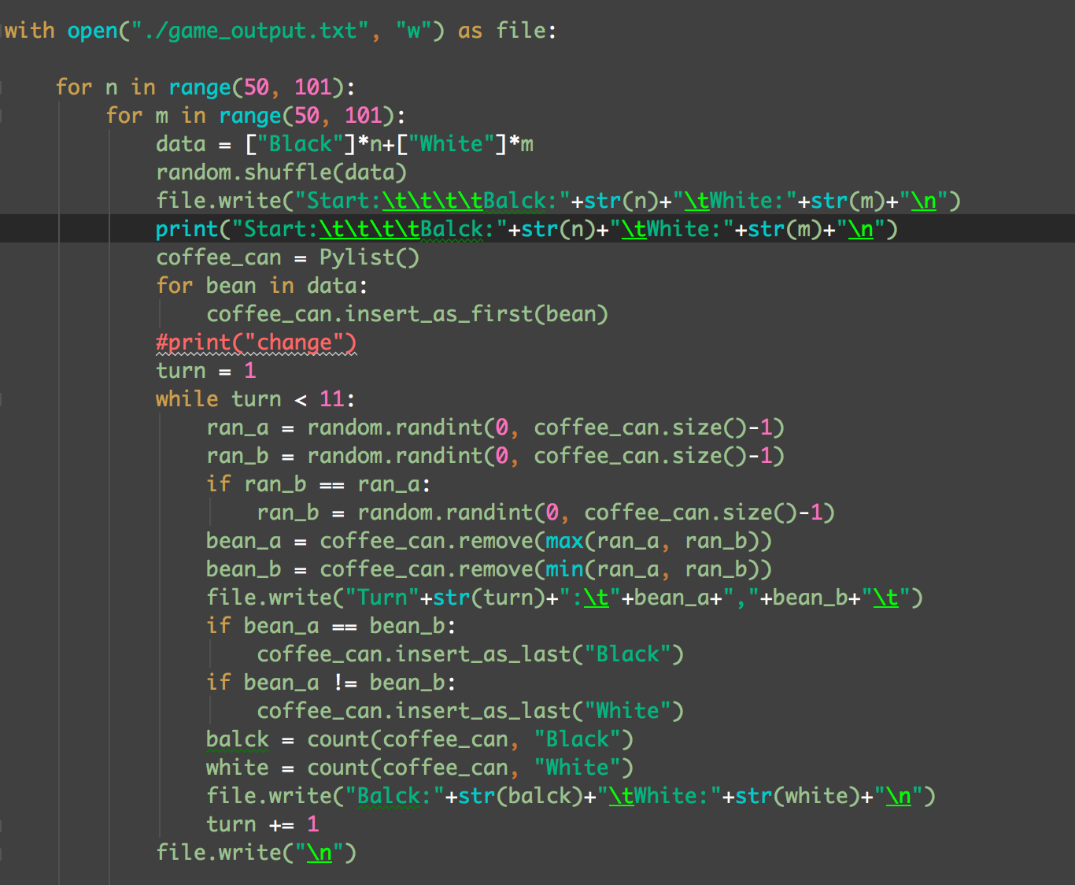

The result is stored in the file game_output.txt

For more information about the rewritten list class, please check the file: coffee_can_pylist.py for source code.

**2.** 构造一组输入数据，存入list结构，调用list接口，依次调用测试下列接口

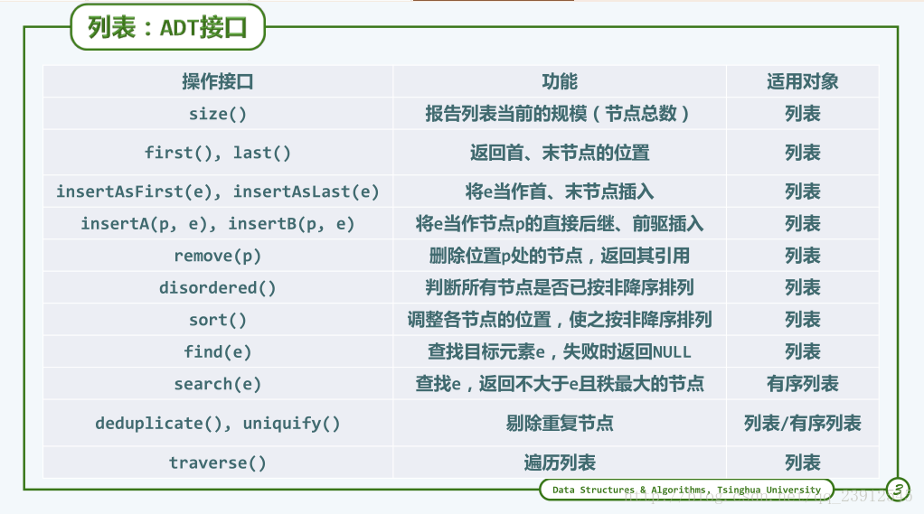

the test program in the left and the output in the right:

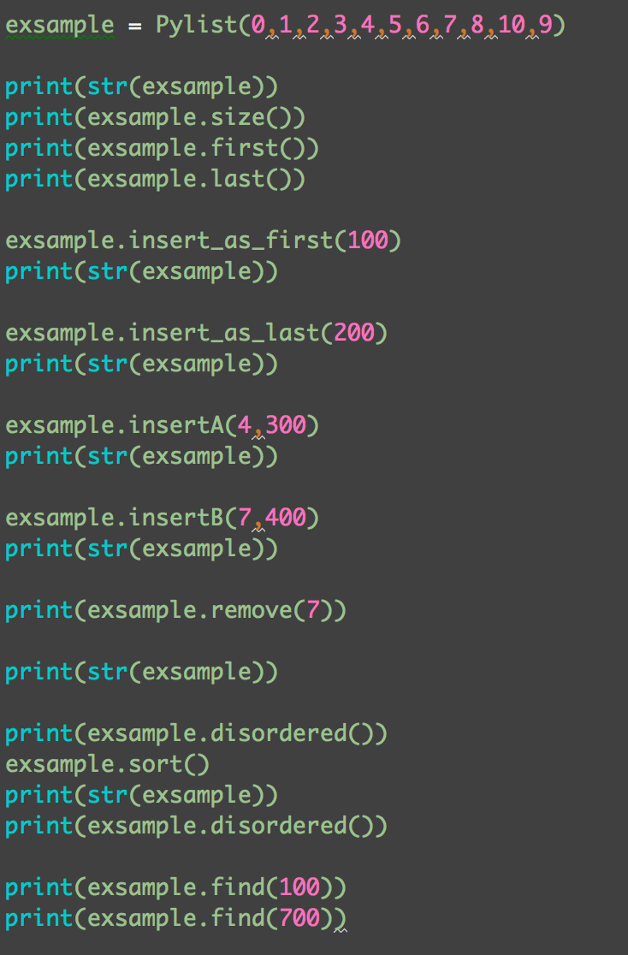The source code: pylist.py

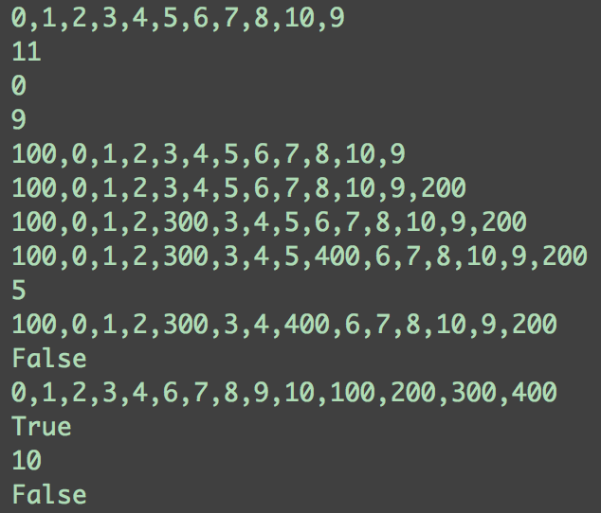

**3.** 常见排序算法时间复杂度分析测试

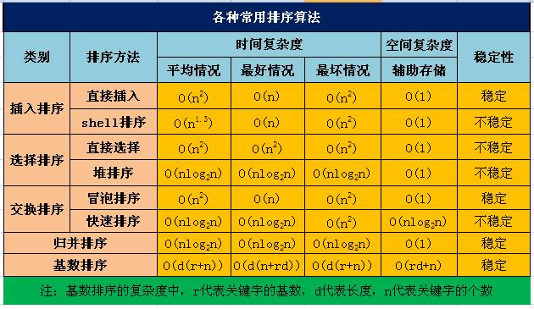

学会分析算法的时间复杂度。代码实现7种排序算法（可参考网上资料），并给出不同规模（1000,10000,10000）下数字排序的运行时间

Source code: 7kind_sort_test.py

|  |  |  |  |
| --- | --- | --- | --- |
| sort algorithms | Time(s) for different sizes | | |
| 100,0 | 100,00 | 100,00 |
| Insert sort 直接插入排序 | 0.021037 | 2.25501 | 2.44149 |
| Shell sort shell排序 | 0.070585 | 9.08224 | 9.67151 |
| Select sort 简单选择排序 | 0.043516 | 4.39137 | 4.60550 |
| Heap sort 堆排序 | 0.005799 | 0.11467 | 0.10802 |
| Bubble sort 冒泡排序 | 0.043715 | 4.40686 | 4.56962 |
| Quick sort 快速排序 | 0.059198 | 5.48732 | 5.49152 |
| Merge sort 归并排序 | 3.099441 e-06 | 2.86102 e-06 | 3.09944 e-06 |